Test Case ID
TC_001

Test Case Name
Search based on date filter

Test Scenario
User selected a valid date range and search for all logs types in all folders

Preconditions
N/A

Test Steps
- Launch the application and select a valid From Date and To Date
- Keep all other fields as default (All)
- Click the Search button.

Expected Result
- Verify that all displayed records fall within the selected date range.
- Verify that records beyond the date range are not displayed.

Actual Result

  - After selecting Date range

Records are displayed successfully based on the selected date range 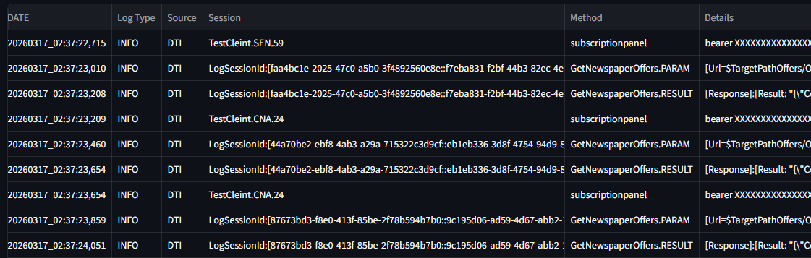

  - After selecting Date range
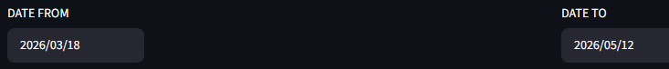
The records shows No matching logs found


Test Case ID
TC_002

Test Case Name
Search based on date filter

Test Scenario
User selected an invalid date range and search for all logs types in all folders.

Preconditions
N/A

Test Steps
- Launch the application and select a valid From Date and To Date
- Keep all other fields as default (All)
- Click the Search button.

Expected Result
1)Verify that an error message is displayed when the “Date From” value is greater than the “Date to” value.
Actual Result

  - After selecting "Date from” value which is greater than the “Date to” value
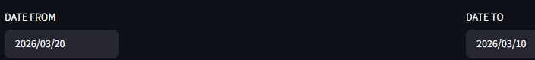
The record shows
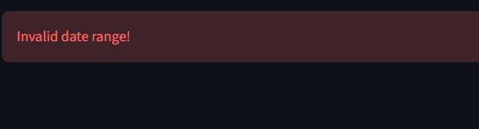

Test Case ID
TC_003

Test Case Name
Search based on Folder and Type filter

Test Scenario
User selected folder and type and search for logs types in folders.

Preconditions
N/A

Test Steps
- Launch the application and a valid From Date and To Date
- select Folder and Type.
- Click the Search button.

Expected Result
Verify that all records displayed successfully based on selected folder and Type.

Actual Result

- After selecting a Folder and a Type

Records displayed successfully based on selecting a Folder and a Type.
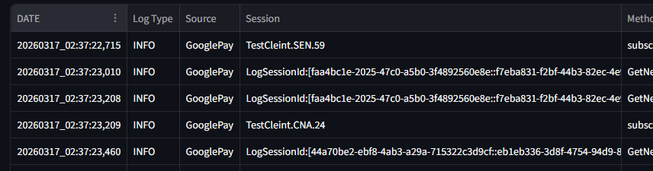
- After multiselecting Folder and Type
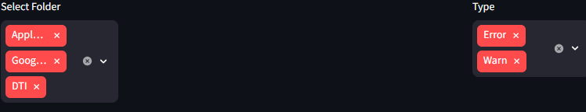

Records displayed successfully
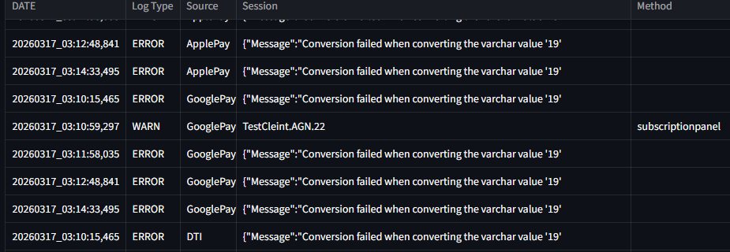

- After selecting all Folders and multiselecting Type
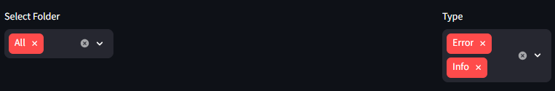

Records displayed successfully
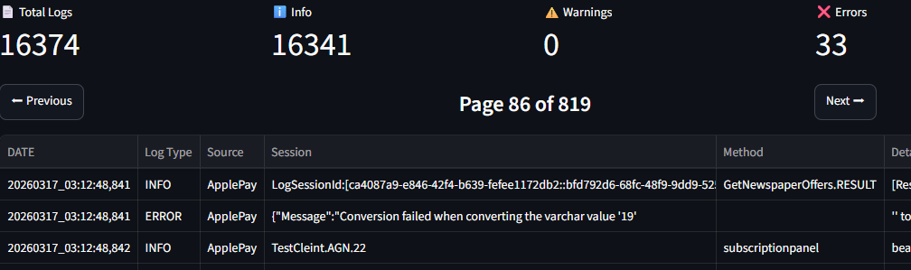

- After selecting all Folders and all Types
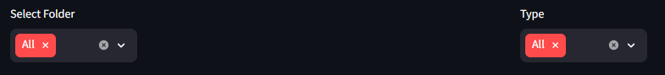
records displayed successfully
